# Table of Contents

Table of Contents iii

1.0 Introduction 4

2.0 Voucher Management System (VMS) 6

3.0 Proposed End to End Solution 7

4.0 Proposed SOA and API Integrations 13

5.0 New IT Capability Requirement 14

5.1 New Capability Requirement in CRM 14

# Introduction

The FRD outlines the key objectives and functional requirements for the implementation of a Coupon Selling process aimed at promoting Fiber-to-the-Home (FTTH) services, as per the directive from the Product Development team. However, the solution is also designed to facilitate the future requirements of the other voucher management requirement of SLT. The E2E process includes two marked sub-processes, each designed to facilitate efficient voucher management and redemption for FTTH new connections.

* 1. **Voucher Distribution Management:**

This sub-process entails the sale and distribution of vouchers, which will be managed through ERP System. While no new IT developments are required, configuration adjustments within these systems are necessary to seamlessly integrate the Coupon Selling process. The primary objective is to optimize the voucher distribution workflow, ensuring accuracy, transparency, and efficiency in voucher sales operations.

* 1. **Redeem Coupon for FTTH New Connections:**

Recognizing the limitations of the ERP system in handling coupon redemption for FTTH new connections, the solution involves repurposing the Voucher Management System developed by the Digital Platform team for SME business endeavors. This system will serve as the backbone for facilitating the redemption process, and streamlining customer onboarding for FTTH services. By leveraging existing technology infrastructure, the goal is to enhance operational efficiency and provide a seamless experience for customers redeeming coupons.

Through the successful implementation of these sub-processes, the organization aims to achieve the following objectives:

* Increase promotion and uptake of FTTH services through targeted coupon selling strategies as the immediate business requirement.
* Improve operational efficiency in voucher distribution and redemption processes.
* Enhance customer experience by providing a seamless and user-friendly coupon redemption process.
* Optimize resource utilization by repurposing existing IT solutions for voucher management.

Overall, the FRD serves as a blueprint for the development and implementation of the Coupon Selling process, outlining the functional requirements and objectives essential for achieving success in promoting FTTH services. It emphasizes the importance of leveraging existing technology infrastructure while aligning with organizational goals and customer needs.

# 2.0 Voucher Management System (VMS)

Since it is difficult to handle this process in ERP, we are seeking to reuse the Voucher Management System already developed for SME business by the Digital Platform team including minimum developments. For that, it requires the following capabilities and requirements in VMS.

1. The VMS table shall have the following minimum parameters.

**Parent Coupon ID| Sub Coupon ID| Coupon Offer Name| Coupon Activated Date| Coupon Issued Date| Coupon Expire Date| Coupon Face Value| Sub Coupon Status**

1. VMS has to validate the coupon by the Sub Coupon ID and Coupon Status. Coupon Status will have the following status.

**Active| Reserved| Issued| Expired| Cancel| Inactive| Abounded**

1. VMS support to change the status from **Active -> Reserved -> Issued** by the external triggers. If cancellation API calls, **Reserved -> Active** status back. Or From any status to ‘Cancel’ or ‘Abounded’ status.
2. VMS has to run its own process daily and change the Coupon Status to ‘**Expired**’ if the expiration date has passed.
3. Admin account has to be developed/Configured to Maintain Create, Modify, and Delete records in VMS table.
4. Provision of a comprehensive dashboard view, facilitating real-time monitoring and analysis of data within the VMS table.
5. Facilitating the Bulk Upload of Data to the VMS Table.
6. Required to provide APIs for external triggers from SOA, ERP, Cashiering, CRM etc. based on the requirements.
7. Required to data synchronize from ERP to VMS.

# 3.0 Proposed End to End Solution

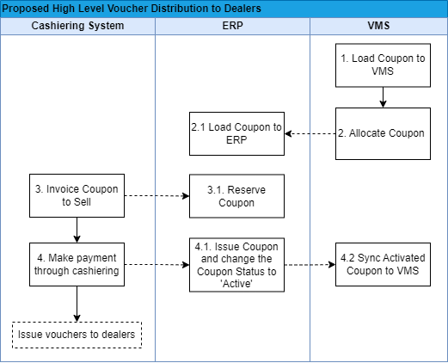

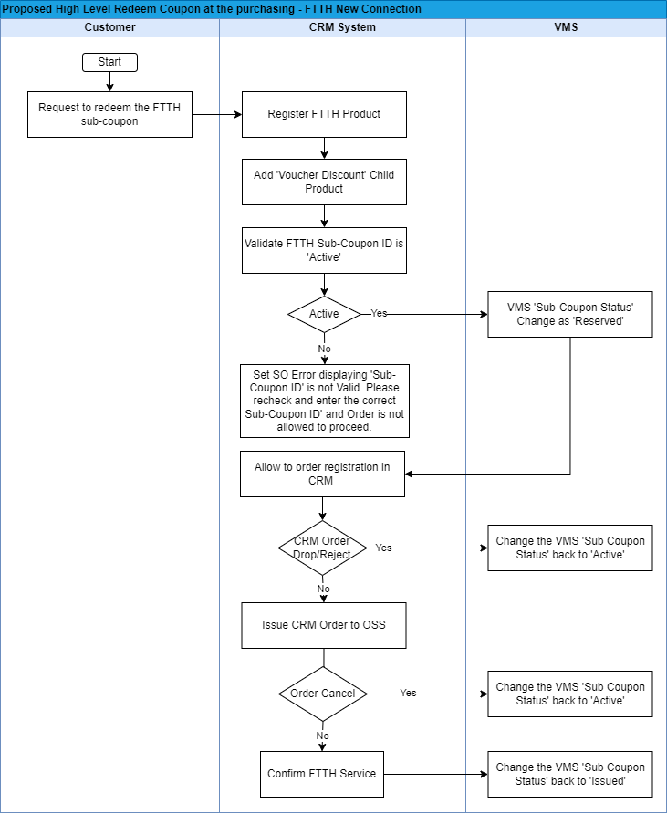

3.1 **Key functionalities/Activities**

|  |  |  |  |  |
| --- | --- | --- | --- | --- |
| **Function/Activity** | **Description** | **Input/Outputs** | **Integrated Systems** | **Business Rules/ Remarks** |
| Proposed High level Voucher Distribution to Dealers | | | | |
| 1. Load Coupon to VMS | Upload Coupon-related details one by one or in Bulk to VMS.  Also, Users can enter coupon codes manually or through a digital interface. | Inputs  Parent Coupon ID|  Sub Coupon ID| Coupon Offer Name|  Coupon Issue Date|  Coupon Activated Date  Coupon Expire Date|  Coupon Face Value|  Sub Coupon Status| | VMS | The system shall facilitate the Bulk Upload of Data to the VMS Table.  The character limitation for CRM is 100 characters. Therefore, for both ERP and CRM, the Sub-Coupon ID's character limitation should be 100 characters.  Parent Coupon ID:  (Generated from the VMS side and character limitation is 100)  Sub Coupon ID:  (Generated from the VMS side and character limitation is 100) |
| 2. Allocate Coupon | Allocate coupons from VMS and send them to the ERP to issue out. | Inputs  Parent Coupon ID|  Sub Coupon ID| Coupon Offer Name|  Coupon Issue Date|  Coupon Activated Date  Coupon Expire Date|  Coupon Face Value|  Sub Coupon Status| | VMS |  |
| 2.1. Load Coupon to ERP | Load the **allocated** coupon to ERP from VMS. | Inputs  Parent Coupon ID|  Coupon Offer Name|  Coupon Issue Date|  Coupon Activated Date  Coupon Expire Date|  Coupon Face Value|  Sub Coupon Status| | ERP | The Sub-Coupon ID should not synchronize with the ERP. |
| 3. Invoice Coupon to Sell | Generate Invoice to sell. |  | Cashiering System |  |
| 3.1. Reserve Coupon | Reserve coupons for Dealers. | Dealer Name| Mobile Number | ERP |  |
| 4. Make payment through cashiering | Dealers have the option to collect Vouchers by making payments through the cashiering system, where they can interact with Coupon Managers. |  | Cashiering System |  |
| 4.1. Issue Coupon and Change the Coupon Status to 'Active' | The system enables the coupon manager to upload coupons and subsequently update the Coupon status to 'Active,' by ensuring that these coupons are already distributed to dealers.  These activated coupon details should be synced to the VMS system. | Inputs  Sub Coupon ID|  Sub Coupon Status | ERP/VMS | The system shall facilitate to select the Sub Coupon IDs in ‘Pending’ status and be changed to the ‘Active’ status. |
| 4.2 Sync Activated Coupon to VMS | Call the VMS API to synchronize the activated coupon list from ERP to VMS | Inputs  Sub Coupon ID | ERP/VMS | This has to be done via API. (Required from VMS) |
| Proposed High-level Redeem Coupon at the purchasing – FTTH New Connection | | | | |
| **Function/Activity** | **Description** | **Input/Outputs** | **Integrated Systems** | **Business Rules/ Remarks** |
| Request to redeem the FTTH sub-coupon | Request the customer to redeem the FTTH New connection sub-coupon by visiting to the SLT RTOM office. |  | NA |  |
| Register FTTH Product | Register FTTH New Connection process in CRM. | Mandatory and required attributes for FTTH Product registration. | CRM |  |
| Add 'Voucher Discount' Child Product | Configure a new child product ‘Voucher Discount’ under FTTH product and Add it. |  | CRM |  |
| Validate FTTH Sub-Coupon ID is 'Active' | CRM user scans and updates the ‘Sub Coupon ID’ in the product attribute and sends it to VMS.  Validate FTTH Sub-Coupon ID is in 'Active' status.  If the FTTH Sub-Coupon ID is in 'Active' status, then the VMS table 'Sub-Coupon Status' should be updated/ changed to 'Reserved' and passed the latest status to CRM. | Inputs  Sub-Coupon ID  Outputs  _Coupon Offer Name  _Coupon Face Value  _Sub Coupon Status [ SUCCESS|FAIL]  _Status Description | CRM/VMS/  SOA | The following parameters should be returned once the provided Sub-Coupon ID is in ‘Active’ status.  _Coupon Offer _Coupon Offer Name  _Coupon Face Value  _Sub Coupon Status [ SUCCESS|FAIL]  _Status Description  Otherwise, return the ‘FAIL’ request and the ‘Sub Coupon Status’.  . |
| VMS 'Sub-Coupon Status' Change as 'Reserved' | If the FTTH Sub-Coupon ID is in 'Active' status, then the VMS table 'Sub-Coupon Status' should be updated/ changed to 'Reserved' and passed the latest status to CRM. | Sub-Coupon ID | VMS |  |
| Allow to order registration in CRM | If the FTTH Sub-Coupon ID is in 'Active' status, then allow to order registration in CRM. | NA | CRM |  |
| Change the VMS 'Sub Coupon Status' back to 'Active' | If the order is rejected, Canceled, or dropped from the CRM, then the VMS table 'Sub-Coupon Status' should be updated/ changed back to 'Active' status. | Order Cancel request | VMS/CRM  /SOA | This scenario shall cover both order is dropped by CRM before submission to OSS and also the order is cancelled by CRM after order is submitted to OSS |
| Issue CRM Order to OSS | Submit the CRM order to OSS. | NA | CRM |  |
| Confirm FTTH Service | Completion of OSS SO. | NA | OSS |  |
| Change the VMS 'Sub Coupon Status' to 'Issued' | Once the OSS service order is completed, then the VMS table 'Sub-Coupon Status' should be updated/ changed to 'Issued' status based on the CRM Status. | Order completion status | VMS/CRM |  |

**3.2 Other functionalities in VMS**

|  |  |
| --- | --- |
| **Function** | **Description** |
| Change the VMS 'Sub Coupon Status' to ' Expired’ | VMS has to run its own process daily and change the Coupon Status to ‘Expired’ if the expiration date has passed. |
| Dashboard view | Provision of a comprehensive customizable dashboard view, facilitating real-time monitoring and analysis of data within the VMS table including:   * **Overview of Voucher Usage**: Display an overview of voucher usage, including the total number of vouchers Active, Reserved, Issued, and Expired. * **Value of the Vouchers in VMS**: Total value of the Vouchers in VMS based on Coupon Offer Name and Status * **Redemption Trends:** Show trends in voucher redemption over time, including daily, weekly, or monthly redemption rates. * **Customizable Reporting**: Allow users to generate customizable reports. |
| User Privileges | The **Business Admin User Account** has to be developed to Maintain the Create, Modify, and Delete records in the VMS table.  The **Normal User Account** has to be developed to view the Data, Dashboards and report generations. |
| Bulk Upload Data to the VMS Table | Facilitating the Bulk Upload of Data to the VMS Table manually (Using an Excel File) or through a digital interface.  Additionally, there should be a capability to edit coupon-related details individually only by the Business Admin User |

# 4.0 Proposed SOA and API Integrations

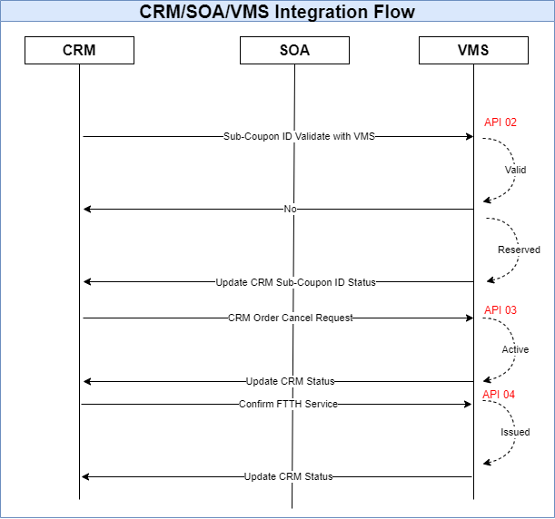

|  |  |  |  |
| --- | --- | --- | --- |
| **API Number** | **Description** | **Inputs** | **Output** |
| API 01 | Coupon validation –IF Status is ‘active’, then Output should be SUCCESS. | Sub-Coupon ID (XXX-XXX-XXX) | _Coupon Offer Name  _Coupon Face Value  _Sub Coupon Status [ SUCCESS|FAIL]  _Status Description |
| API 02 | Coupon reservation.  If Status is ‘active’, then Output should be SUCCESS. | Sub-Coupon ID  Reference Resource Name(Ex:CRM-Attribute)  Reference ID (Ex:Attribute Value) | _Coupon Offer Name  _Coupon Face Value  _Sub Coupon Status [ SUCCESS|FAIL]  _Status Description |
| API 03 | Coupons revert to active (Order Cancel request)  Reserved -> Active | Sub-Coupon ID | _Sub Coupon Status [ SUCCESS|FAIL]  _ Status Description |
| API 04 | Coupon redemption. Reserved -> Issued | Sub-Coupon ID | _Sub Coupon Status [ SUCCESS|FAIL]  _ Status Description |

# 5.0 New IT Capability Requirement

## 5.1 New Capability Requirement in CRM

***5.1.1 Child Product Configuration for AB_Fiber Access Bearer***

Configure a new child product ‘Voucher Discount’ under the AB_Fiber Access Bearer.

AB_Fiber Access Bearer

AB_Initiation Charge

:



AB_Voucher Discount

***5.1.2 Price Plan Details for “AB_Voucher Discount” Child product.***

Configure the following new price plans under the “AB_Voucher Discount” Child product.

|  |  |  |  |  |
| --- | --- | --- | --- | --- |
| **AB_Voucher Discount** | | | | |
| **Product Name** | **Price Plan Name** | **Periodic Charge** | **Discount**  **Charges**  **(without tax)** | **Special Configuration** |
| AB_Voucher Discount | Coupon discount**_**charge | NA | n X 1.00  (For FTTH New connection discount,  n = Coupon Face Value) | The child product will have a parametric price plan of Rs. ‘Coupon Face Value’ X 1.00. This is to appear in the pro-forma invoice and also in the BSS.  If this price plan is added, it is required to appear as a discount for the initiation new connection charge in the Performa invoice in CRM and also it is required to appear as an initiation charge discount in BSS under the customer bill. |

***5.1.3 Attribute configuration***

Insert new attributes under the child product “**AB_Fiber Access Bearer**” as follows.

|  |  |  |  |  |  |  |  |  |
| --- | --- | --- | --- | --- | --- | --- | --- | --- |
| **Attribute Name** | **Attribute Unit** | **Mandatory** | **Break out?** | **Display as asset label?** | **BSS** | **CRM** | **OSS** | **Special configurations required in the attribute comment field** |
| Sub Coupon ID | Text | N | N | Y | Y | Y | Y |  |
| Coupon Offer Name | Text | N | N | Y | Y | Y | Y | This attribute should be non-editable and auto updated from the VMS table based on the sub-coupon ID. |
| Coupon Face value | Text | N | N | Y | Y | Y | Y | This attribute should be non-editable and auto updated from the VMS table based on the sub-coupon ID. |
| Coupon Validation | SUCCESS/FAIL | N | N | Y | Y | Y | Y | This attribute should be auto updated from the VMS table based on the sub-coupon ID. |

***5.1.4 Attribute configuration***

* Provide a facility for front office staff to scan and update the ‘Sub Coupon ID’ in the product attribute and send it to VMS and if the Sub Coupon ID matches, it shall return the Coupon Validation, Coupon Offer Name, and Coupon face value. If the Sub Coupon ID does not match, it shall return the Coupon Validation (Faild).
* If the above ‘Coupon Validation’ attribute is updated as ‘success’, the CRM system needs to automatically add the ‘AB_Voucher Discount’ product, and then the user should be able to select the relevant Voucher discount price plan.
* If the order is dropped by CRM before submission to OSS, then the VMS table 'Sub-Coupon Status' should be updated/ changed back to 'Active' status.
* If the order is rejected or canceled from the OSS after submitting it to the OSS, then the VMS table 'Sub-Coupon Status' should be updated/ changed back to 'Active' status based on the OSS order status in CRM.
* Provision should be made for verifying the availability of Sub-Coupon IDs in the Vendor Management System (VMS) through an individual user interface within the CRM system. (Referring API 01)

|  |  |  |  |
| --- | --- | --- | --- |
| **API Number** | **Description** | **Inputs** | **Output** |
| API 01 | Coupon validation –IF Status is ‘active’, then Output should be SUCCESS. | Sub-Coupon ID (XXX-XXX-XXX) | _Coupon Offer Name  _Coupon Face Value  _Sub Coupon Status [ SUCCESS|FAIL]  _Status Description |